PYTHON

ASSIGNMENT 19-12-2023

READ CSV FILE USING CSV.READER

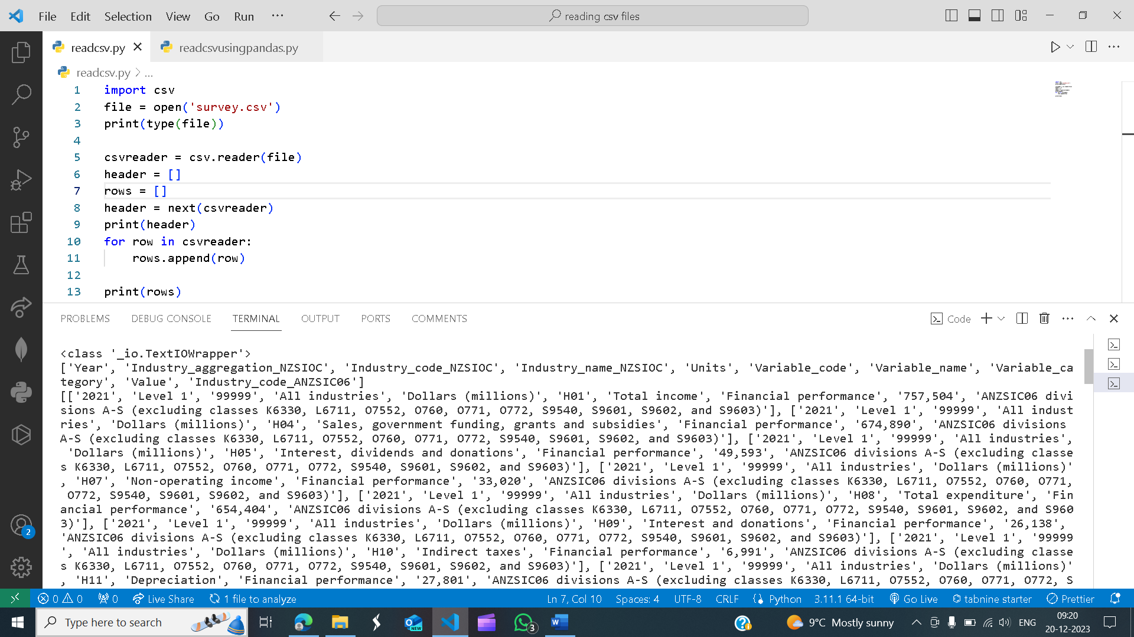

READING CSV FILE USING PANDAS

